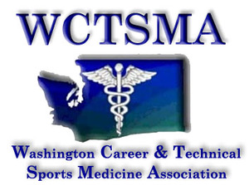

Fall Leadership Conference Schedule
Century Link Field - Seattle, WA
10/6/19 9:00am-12:00pm
Hosted by: Seattle Sounders FC

8:15-8:45 Registration, check in, security
(clear bag policy)
9:00-9:15 Welcome, Introductions
9:15-10:15 Sounders Guest Speakers: Dr. Michael Morris - Sounders Chief Medical Officer
Sounders Front Office Staff TBD
10:15-10:45 Leadership Breakout Activities with State Officers
10:45-10:50 Bathroom Break
10:50-11:00 Scavenger hunt rules
11:05-12:15 Leadership Scavenger Hunt throughout the stadium
12:15-12:30 Group Picture on North End of the stadium
12:30 Released to seats for the game

